Part Number: PT747-12160
Kit Contents
Item # | Quantity Reqd. | Description
1 | 1 | Graphic, Lower Body RH
2 | 1 | Graphic, Lower Body LH
3
Hardware Bag Contents
Item # | Quantity Reqd. | Description
1
2
Additional Items Required For Installation
Item # | Quantity Reqd. | Description
1
2
3
Conflicts
None
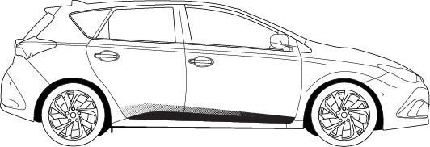
Recommended Tools
Care must be taken when installing this accessory to ensure damage does not occur to the vehicle. The installation of this accessory should follow approved guidelines to ensure a quality installation.

These guidelines can be found in the "Accessory
Installation Practices" document.

This document covers such items as:-
• Vehicle Protection (use of covers and blankets, cleaning chemicals, etc.).
• Safety (eye protection, rechecking torque procedure, etc.).
• Vehicle Disassembly/Reassembly (panel removal, part storage, etc.).
• Electrical Component Disassembly/Reassembly (battery disconnection, connector removal, etc.).

Please see your Scion dealer for a copy of this document.

Personal & Vehicle Protection | Notes
None
Special Tools | Notes
Squeegee | 4" (3M™Gold) or  4" (3M™Silver)
Low Friction Sleeve | 3M SA-1 (OPTIONAL)
Surface Thermometer | Infrared Non-contact
Heat Gun | Master Heat Gun HG-301A or equivalent
Installation Tools | Notes
Lint Free Rags
Spray Bottle | For wetting agent
Special Chemicals | Notes
Cleaner | VDC approved cleaner and cleaning method
Wetting Agent  Note: Solution depends upon ambient temperature of the part and the vehicle surface. If it is difficult to remove bubbles with a squeegee, add one more ml of shampoo. | Johnson’s Baby Shampoo  mixed in one liter of water:  At 65˚F add 2 ml. shampoo  At 70˚F add 3 ml. shampoo At 80˚F add 3.5 ml shampoo  At 90˚F add 4 ml. shampoo
General Applicability
All iM models
Recommended Sequence of Application
Item # | Accessory
1 | Body Side Molding
2 | Lower Body Graphic
*Mandatory
Vehicle Service Parts (may be required for reassembly)
Item # | Quantity Reqd. | Description
Legend
STOP: Damage to the vehicle may occur. Do not proceed until process has been complied with.
OPERATOR SAFETY: Use caution to avoid risk of injury.
CAUTION: A process that must be carefully observed in order to reduce the risk of damage to the accessory/vehicle and to ensure a quality installation.
TOOLS & EQUIPMENT: Used in Figures calls out the specific tools and equipment recommended for this process.
REVISION MARK: This mark highlights a change in installation with respect to previous issue.
SAFETY TORQUE: This mark indicates that torque is related to safety.
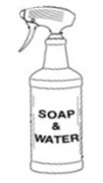
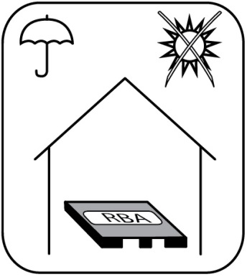
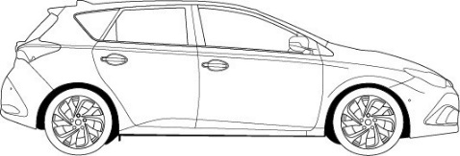
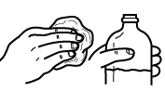
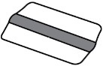
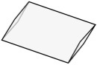
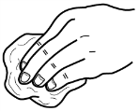
Storage
90˚F

OK

65˚F

Installation Temperature
Cleaner
Squeegee
Sleeve (Optional)
Lint Free
Lower Body Graphic LH
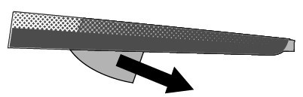
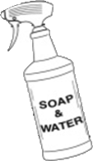
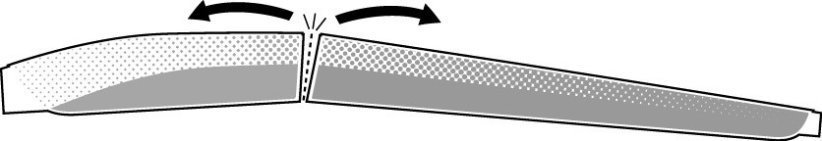
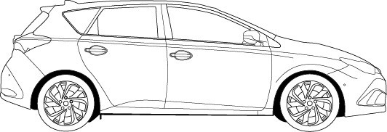
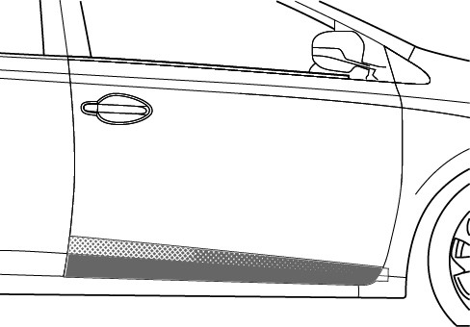
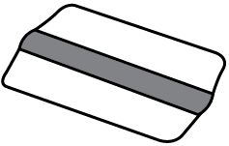
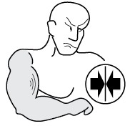
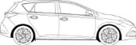
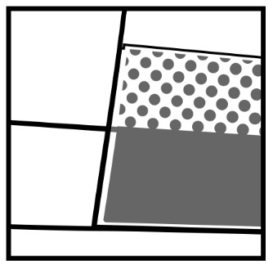
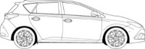
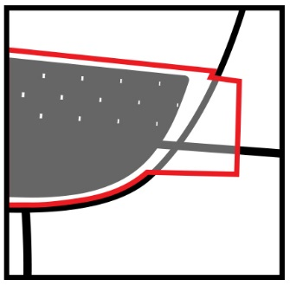
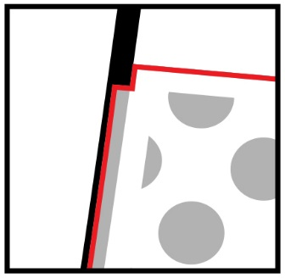
3
2
1
DRY
b
CLEAN
a
Lower Body Graphic RH
SQUEEGEE
Do not remove pre-mask paper until after rear door graphic is applied
1
2
ALIGN
Align bottom edge of pre-mask paper to bottom of door panel
ALIGN
Align notch to door edge
5
6
4
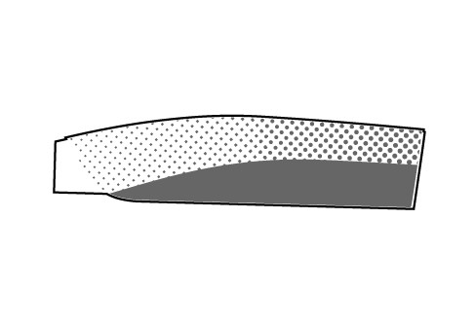
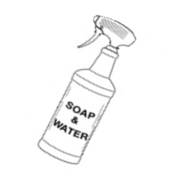
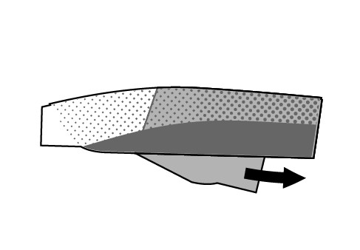
7
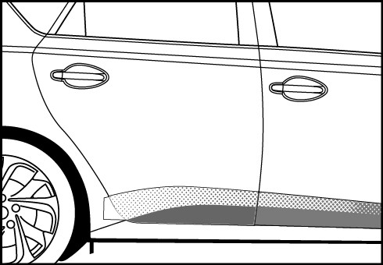
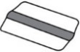
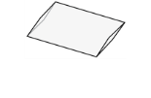
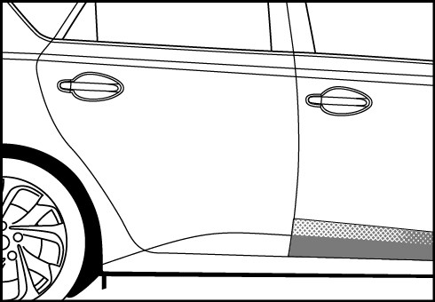
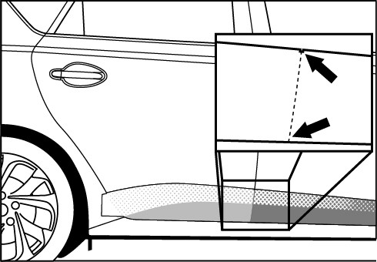
9
SQUEEGEE

= OPTIONAL
SLEEVE
8

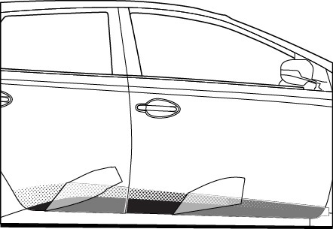
10
180°
PULL
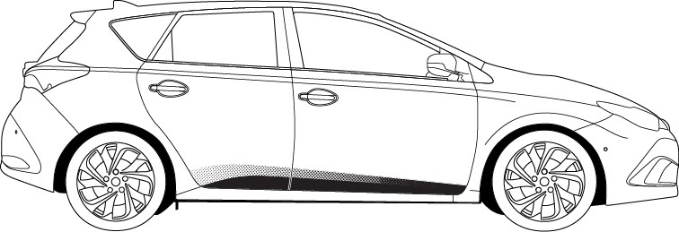
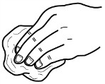
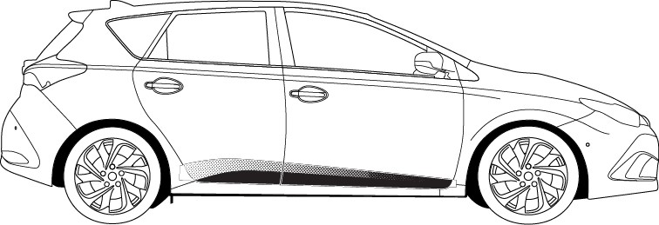
12
DRY
Repeat steps 1 – 12 on driver side
11
SQUEEGEE

Accessory Function Checks
Proper adhesion – visual
Proper adhesion – physical

Proper alignment – cross-car

Vehicle Function Checks

Vehicle Appearance Check
After accessory installation and removal of protective cover(s), perform a visual inspection.

Bubbles, loose and lifting edges

With light pressure, rub hand over top of part and if crackling sound occurs, re- squeegee. If bubbles cannot be worked out to the nearest edge, replace part.
Part must have a uniform gap around door edge +/- 1.0 mm.

Ensure no damage (including scuffs and scratches) was caused during the installation process.
(For PPO installations, refer to TMS Accessory Quality Shipping Standard.)

